Assignment-27.4:

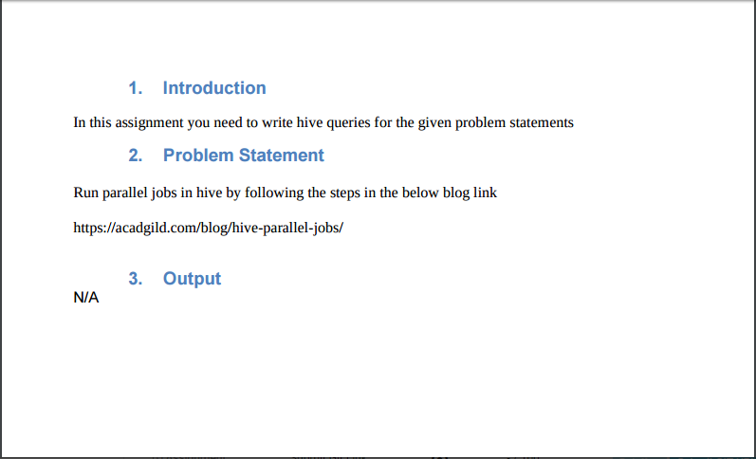

Tables:

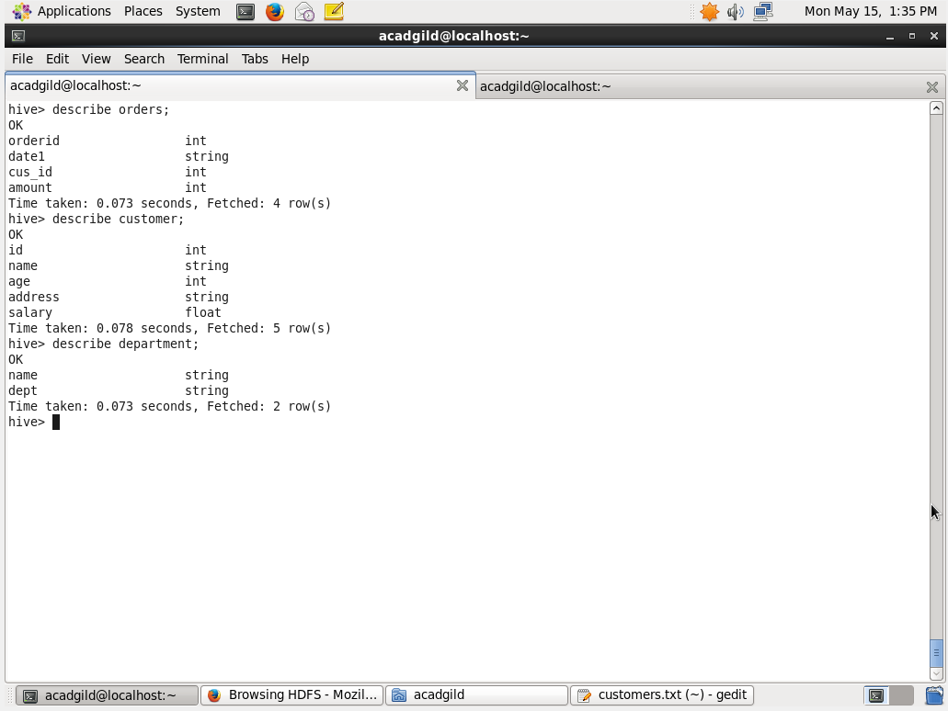

Now we want join these 3 table and display the name, id, department using the below query.

Series execution:

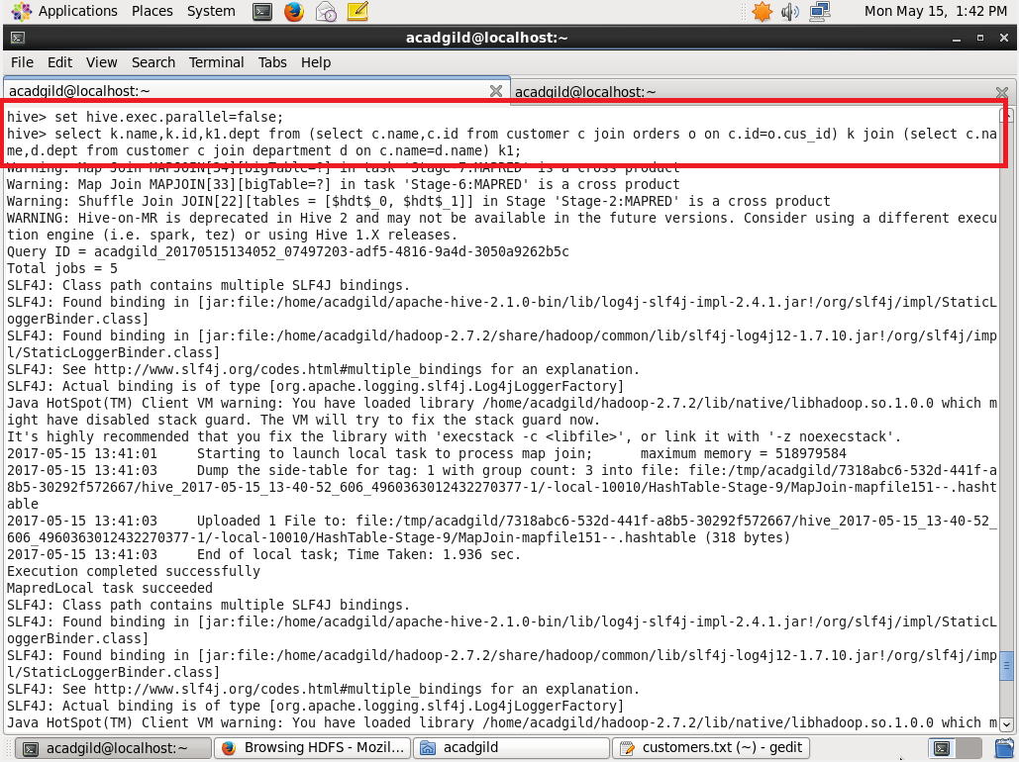

We are setting the parallel-execution type as false, so that the jobs will execute in the series manner.

Jobs are running in series:

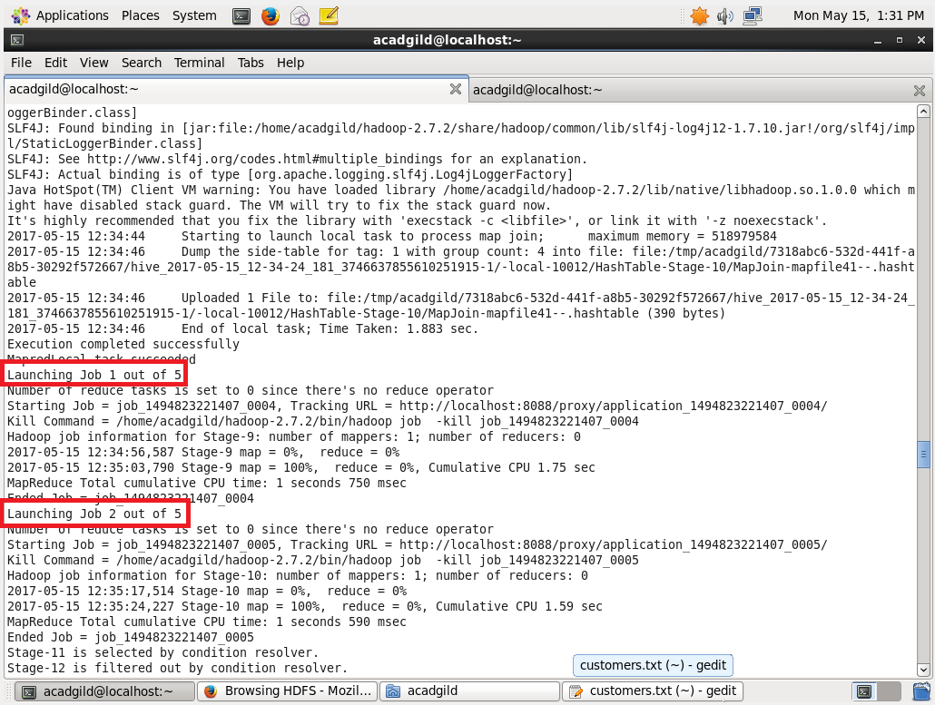

Output:

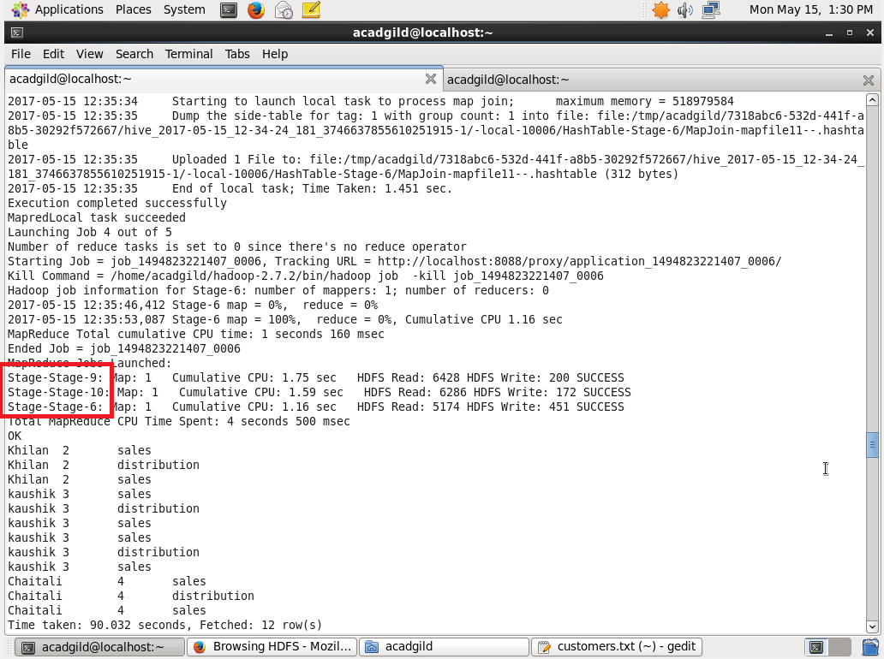

Parallel execution:

In order to run the job in parallel

**Set hive.exec.parallel=true**

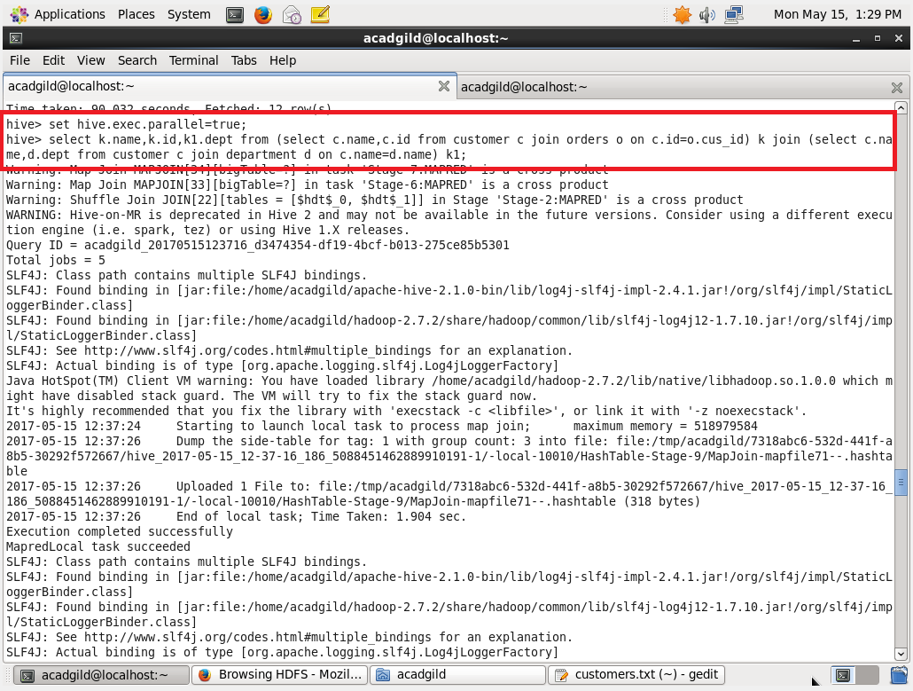

Setting the parallel execution to true. And running the same query.

Jobs are running in parallel:

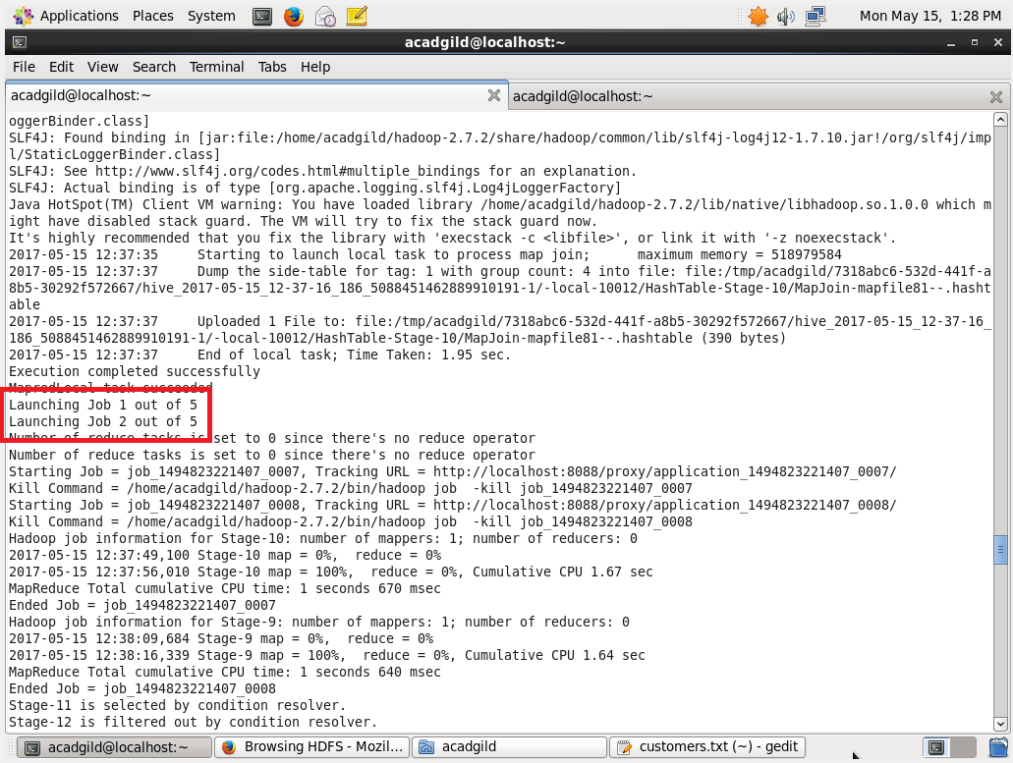

Output:

